Additional feature provided for entering Pension Arrears bills and DA Arrears bills in PPMS Software
Pension Arrears Bills
In the existing PPMS software, once a bill is generated for a particular month against a pensioner, there was no provision to :
- To enter revised pension bill for that particular month
- Pension arrears bill due to revision of pension
- Part of days family pension whenever a family pensioner dies in the middle of the month
- Part of days pension whenever death of pensioner happens in the middle of the month and there is no family pensioner.

In order to facilitate this, new provision is made to enter the Arrears bill.
Login to PPMS using the user ID and Password. In Home screen, one more option is provided for keying in Pension Arrears Bill.
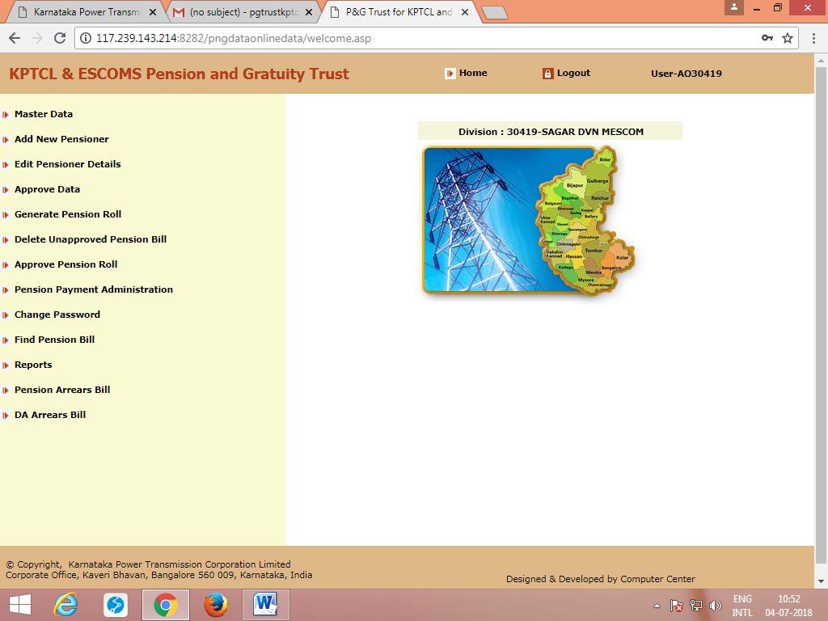
On clicking Pension Arrears Bill, screen shown below appears.

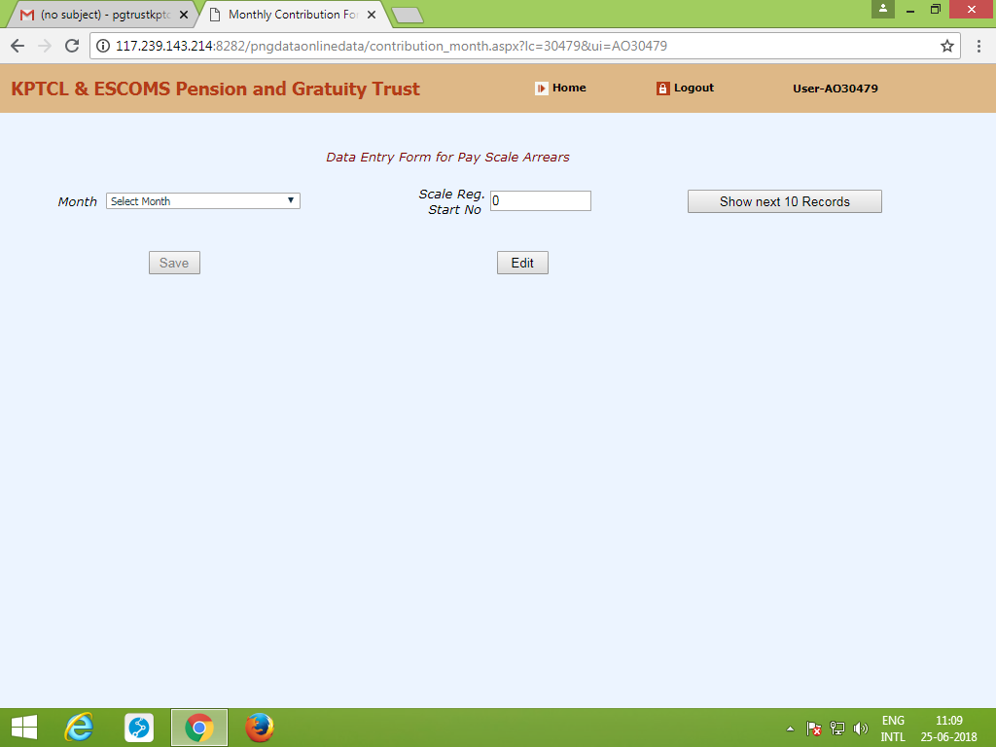

Enter the month and scale Register starting number (which is a mandatory field) and click ‘show next 10 records’. Pension records are displayed in the manner shown below.

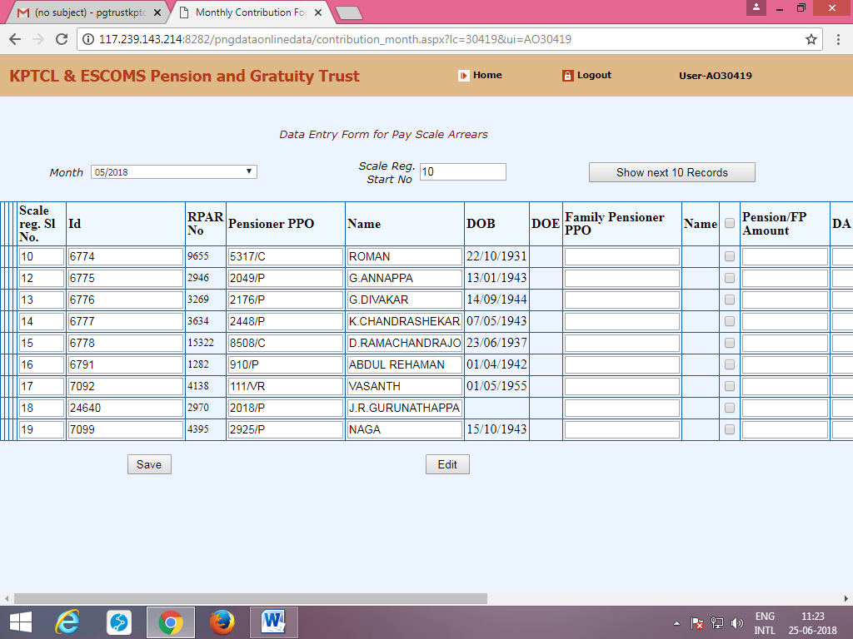’
Tick the check box next to the field ‘Name’ and enter Pension, DA and other deduction details, (if any) and then press ‘save’. (Here, Arrears of Pension, Corresponding DA are to be calculated manually and then, total for the period against each pensioner/family pensioner has be entered in the the appropriate columns provided).
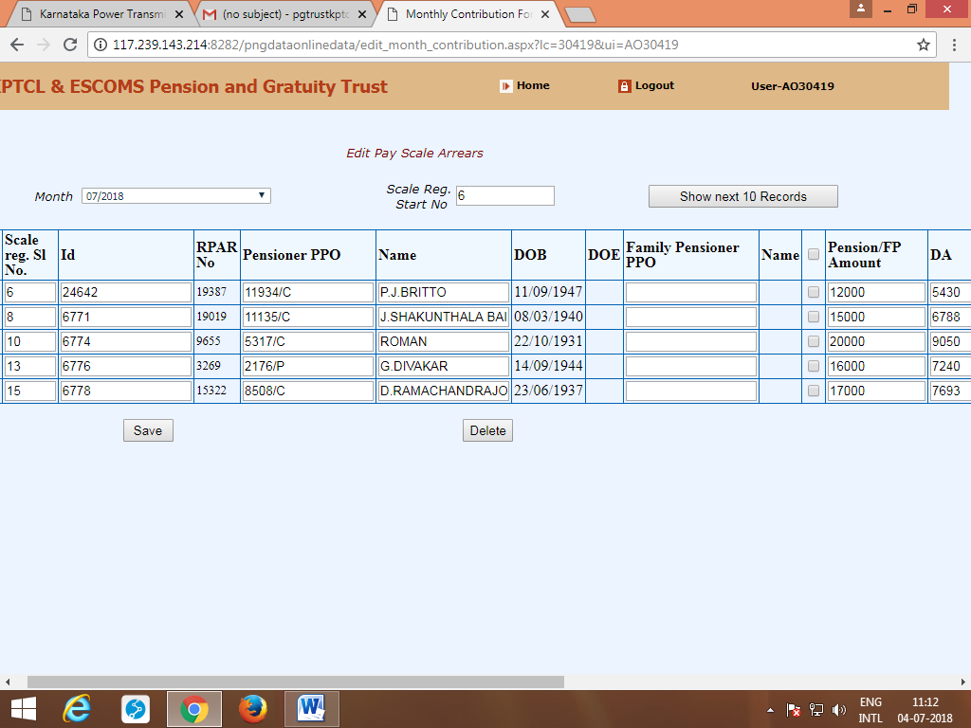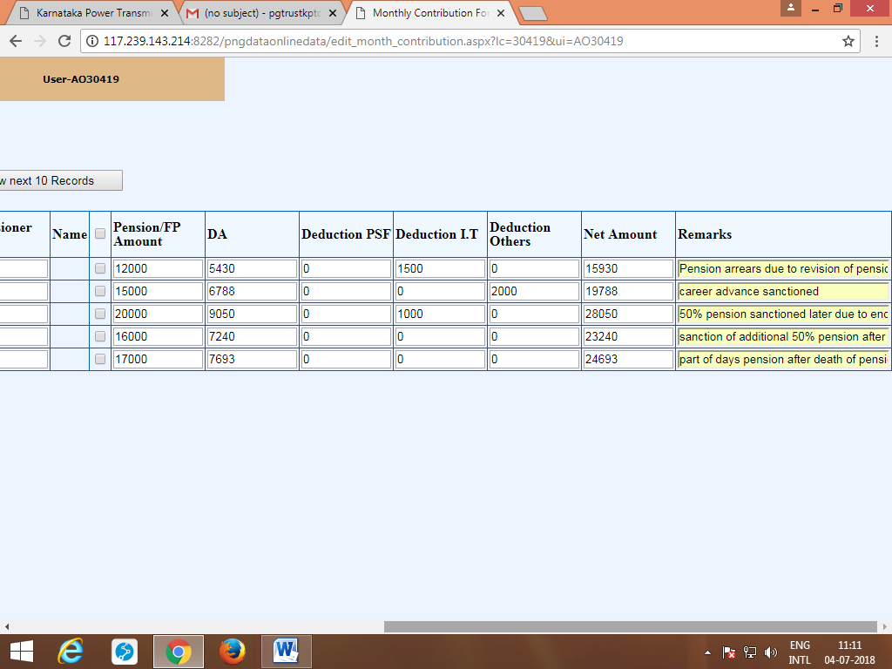
If there is any correction, click Edit, all the records which are entered previously are displayed. Check the box against which correction has to be made and after making corrections click Save.
It should be noted that, ‘Scale Register Sl. No’. in the master data should not be left blank. When it is left blank, all the records are displayed and even if details are entered, error shown below pops up.

Server Error in '/pngwebapp' Application.

Operation is not valid due to the current state of the object.
Description: An unhandled exception occurred during the execution of the current web request. Please review the stack trace for more information about the error and where it originated in the code.
Exception Details: System.InvalidOperationException: Operation is not valid due to the current state of the object.
Source Error:
An unhandled exception was generated during the execution of the current web request. Information regarding the origin and location of the exception can be identified using the exception stack trace below.
Stack Trace:
[InvalidOperationException: Operation is not valid due to the current state of the object.]
System.Web.HttpValueCollection.ThrowIfMaxHttpCollectionKeysExceeded() +2428122
System.Web.HttpValueCollection.FillFromEncodedBytes(Byte[] bytes, Encoding encoding) +58
System.Web.HttpRequest.FillInFormCollection() +159

[HttpException (0x80004005): The URL-encoded form data is not valid.]
System.Web.HttpRequest.FillInFormCollection() +217
System.Web.HttpRequest.get_Form() +104
System.Web.HttpRequest.get_HasForm() +9119215
System.Web.UI.Page.GetCollectionBasedOnMethod(Boolean dontReturnNull) +97
System.Web.UI.Page.DeterminePostBackMode() +69
System.Web.UI.Page.ProcessRequestMain(Boolean includeStagesBeforeAsyncPoint, Boolean includeStagesAfterAsyncPoint) +135

Hence, ‘Scale Register Sl. No.’ has to be filled compulsorily. In case if it is left blank, go to Édit Pensioner Details’ in the Home Menu and enter ‘Scale Register Sl. No.’ and then Approve Data’.
Once the Arrears entries are made against Basic Pension, DA Etc., enter ‘Save’.
You can view ‘’Draft pension roll’
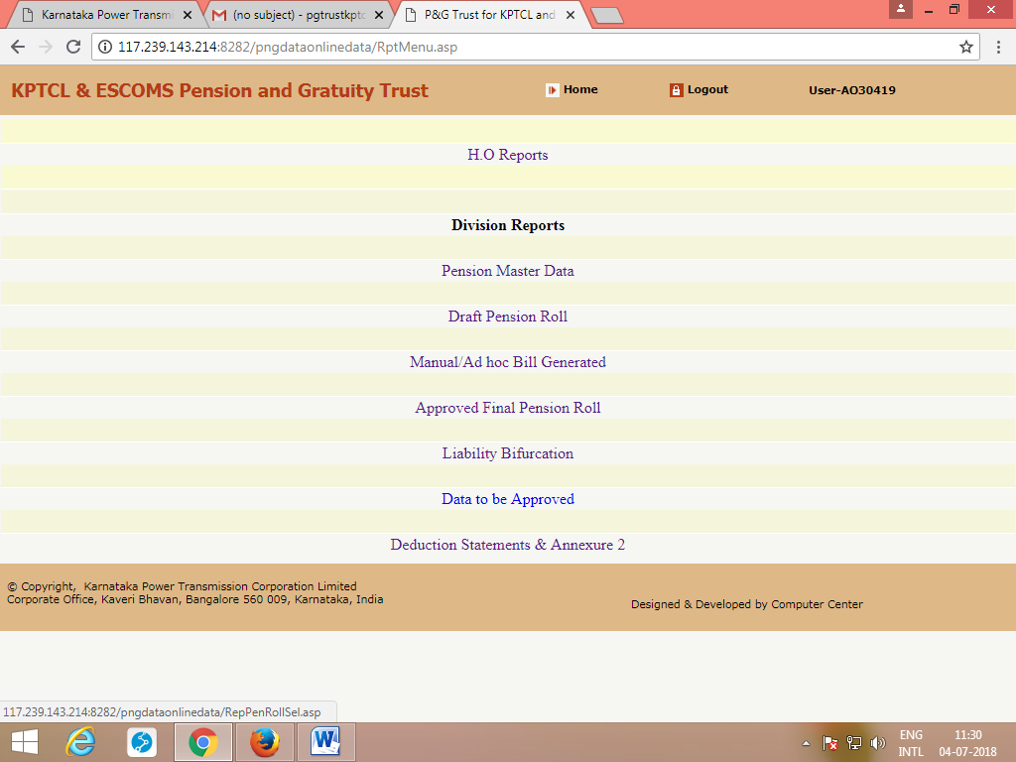
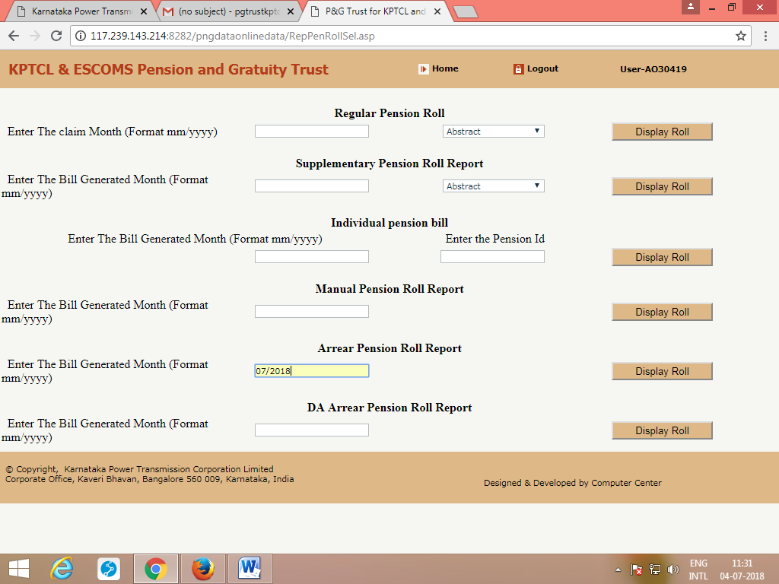
Verify the correctness and then approve the Arrears bill as was done for regular/supplementary roll.
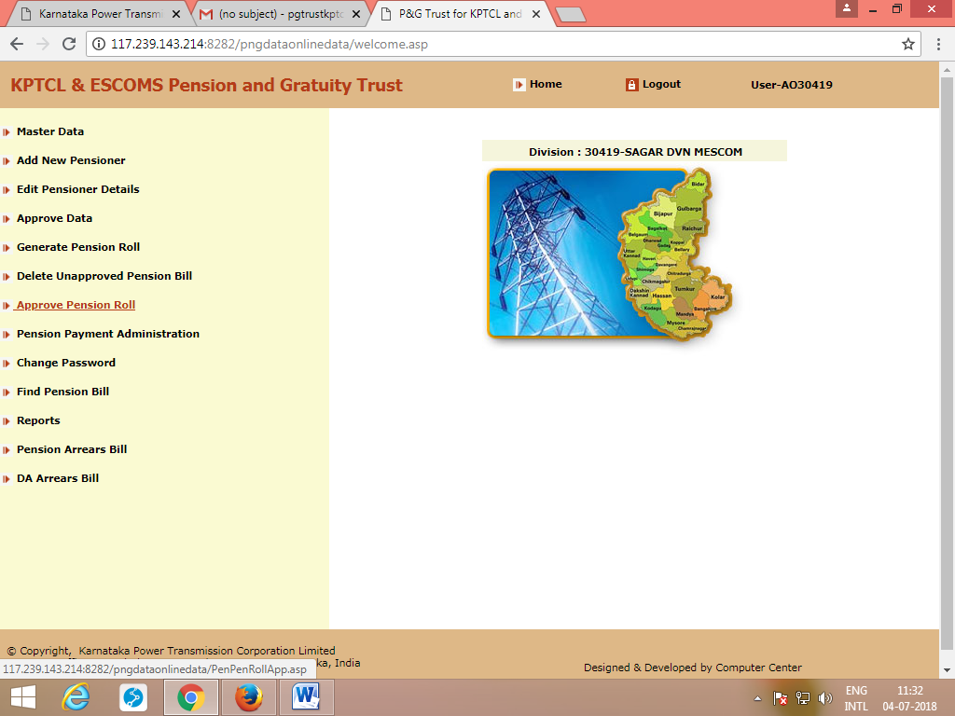
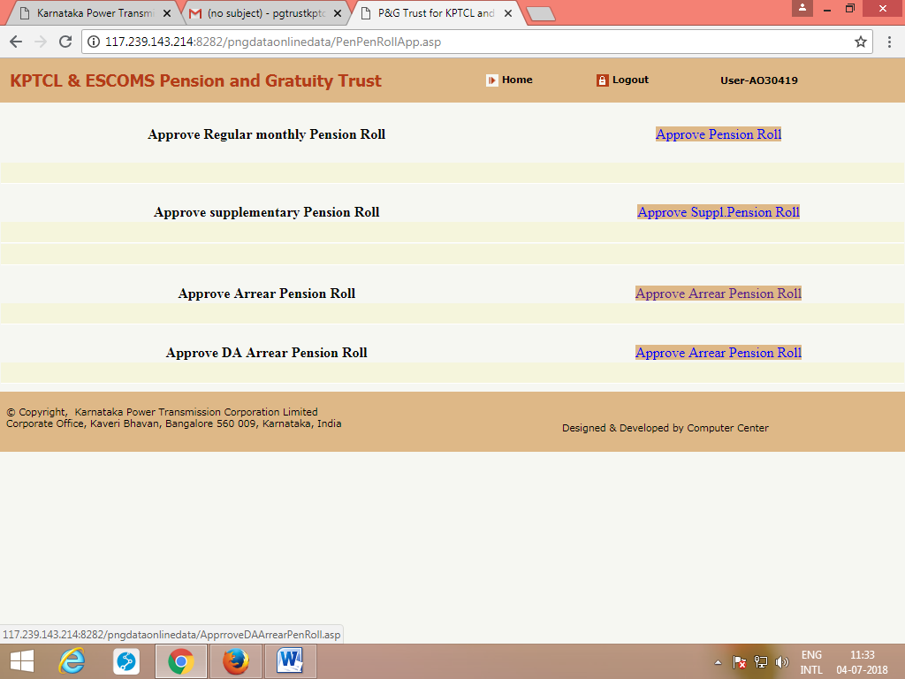
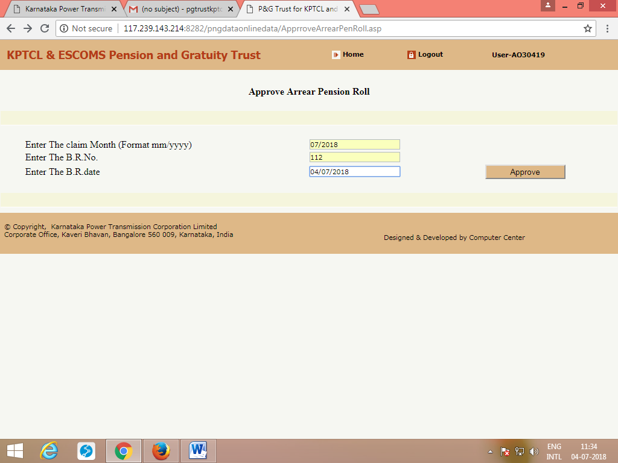

Once Arrears bill is approved, you can take reports of Final Approved roll , Annexure-2, liability bifurcation etc., in the same way as it was obtained for regular/supplementary roll.
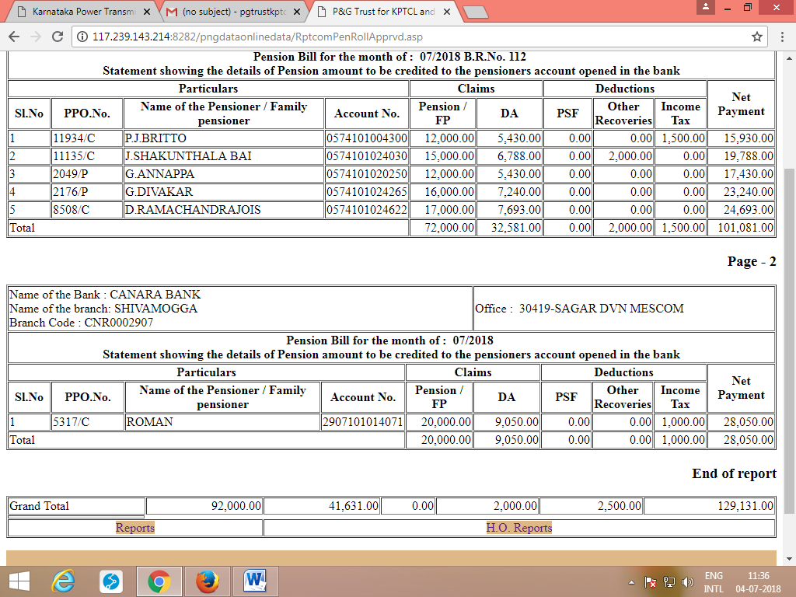

Note : The existing provision for creating supplementary bill has to be used whenever, pension is stopped for want of life certificate or family pension is sanctioned afresh due to death of pensioner.

D.A. Arrears Bill

One more provision has been made for entering D.A. Arrears bill as shown in page 1 below Pension Arrears Bill.

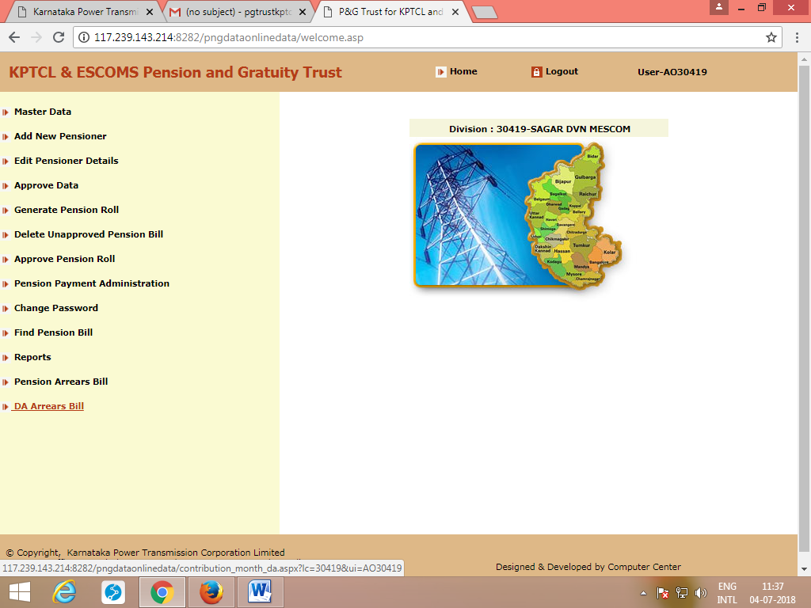
On clicking D.A. Arrears bill, following screen appears. Enter the Month and Scale Register Start No. and then Click Show next 10 Records.

Tick the check box next to the field ‘Name’ and enter D.A. amount and other deduction details, (if any) and then press ‘save’. (Here, Arrears of D.A. has to be calculated manually and then, total for the period against each pensioner/family pensioner has to be entered in the appropriate columns provided).

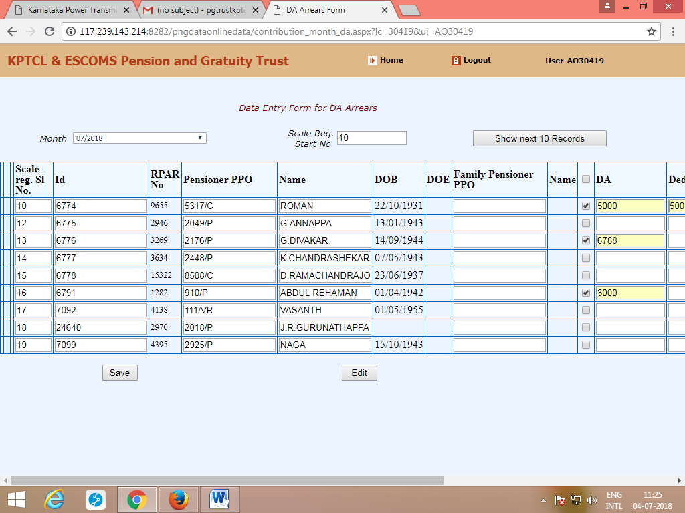

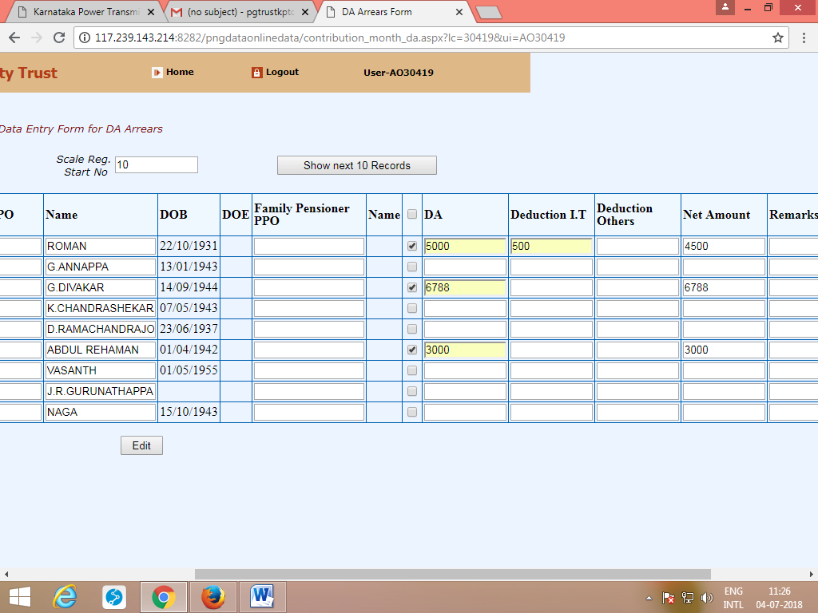
Once the entries are made and clicking Save, the correctness of the same can be verified by clicking ‘Draft Pension Roll’.
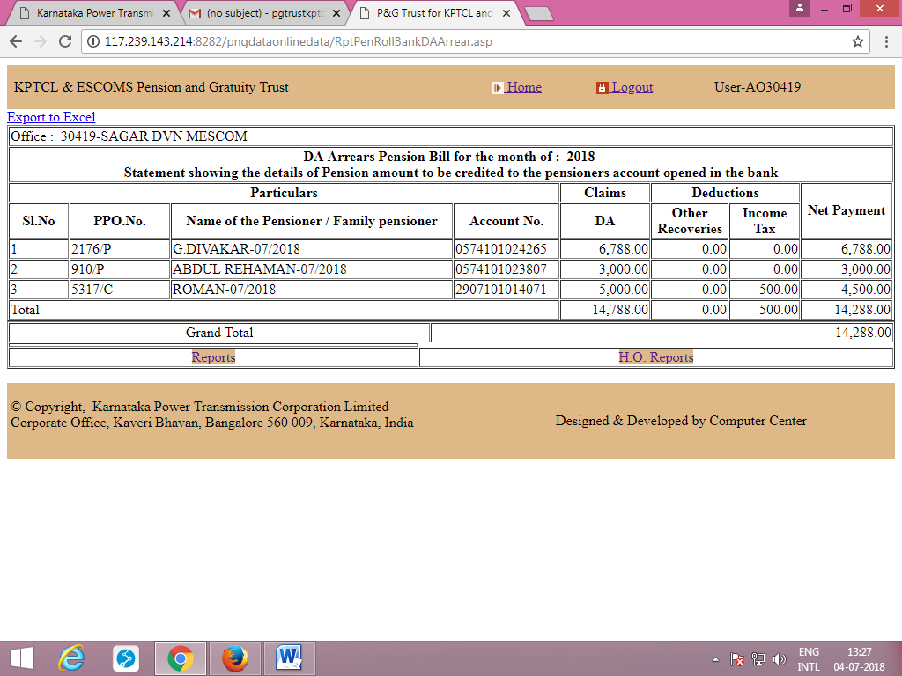

Once draft roll is verified and Approve the roll.
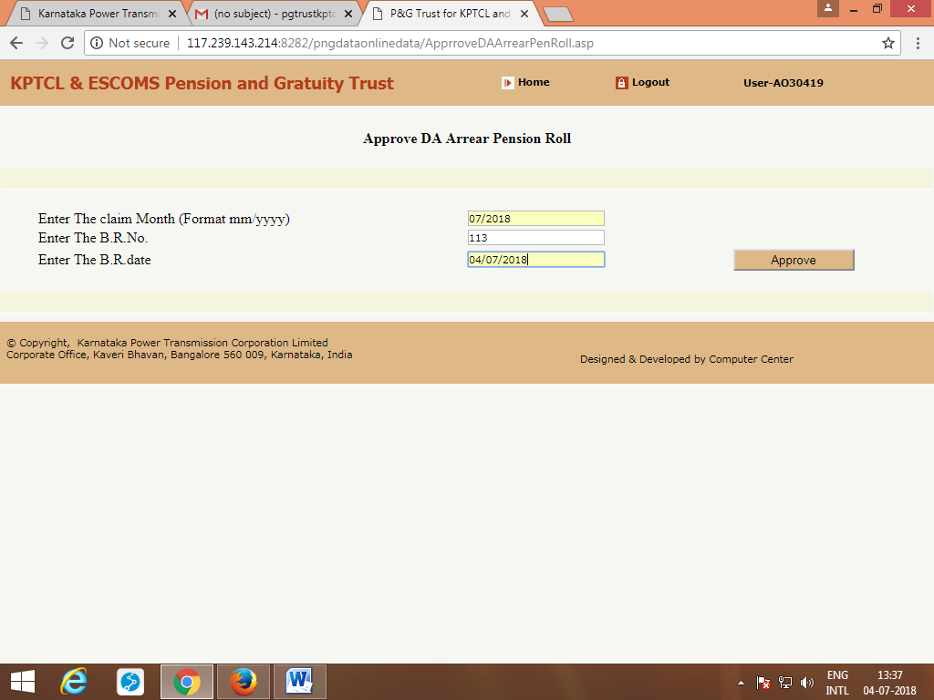

Once, D. A. Arrears bill is approved, Approved final DA arrears bill can be obtained.

